# **Software Engineering Assignment**

**MODULE: 1 SE – Overview of IT industry**

**What is software? What is software engineering?**

It is the opposite of hardware, which describes the physical aspects of computer. Software engineering is the branch of computer science that deals with the design, development, testing, and maintenance of software applications.

**What are the types of software?**

1. **Application Software:**

It is the most common type of software which performs a specific function for the user. A kind of a software that performs specific functions for the end user by interacting directly with in.

Example: Microsoft office

1. **System Software:**

These are used to run a computer application program and hardware. System software coordinates the activities and functions of hardware and software.

Example: Notepad, calculator, etc.

1. **Driver Software:**

Also known as device driver, this software is often a type of system software. Device driver controls the device and peripheral connected to computer.

Example: Audio and video driver

1. **Middleware Software:**

Software that mediates between the system and application software or between two different applications.

Example: Database.

**What is SDLC? Explain each phase of SDLC.**

SDLC stands for software development life cycle. It includes following phases:

1. Planning
2. Analysis
3. Design
4. Implementation
5. Testing and Integration
6. Maintenance

**What is DFD? Create a DFD diagram on flipkart.**

DFD stands for data flow diagram.

0-level:

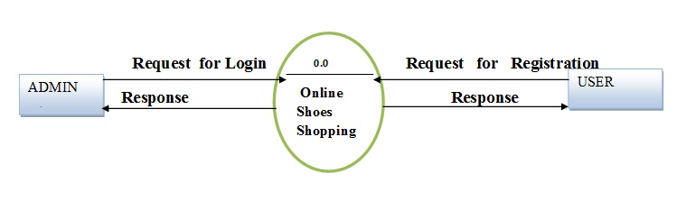

**What is Flowchart? Create a flowchart for the addition of two numbers.**

A flowchart is a type of diagram that represents a workflow or process.

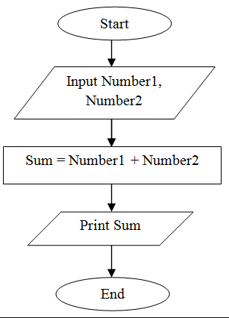

**What is use-case diagram? Create a use case on bill payment on paytm.**

A use case diagram is a graphical depiction of a user's possible interactions with a system.

